NAME:__________________

- Wstaw THERE IS, THERE ARE, IS THERE, ARE THERE
- ______________ some strawberries in the basket.
- ______________ any milk in the fridge?
- ______________ animals in Africa?
- ______________ not any water in the bottle. The bottle is empty.
- ______________ a sandwich with cheese on the plate.
- It is Sunday, ______________ not any students at school.
- ______________ any butter in the fridge?
- ______________ some toys in Simon’s room.
- It is winter, ______________ not any green trees in my garden.
- ______________ not any honey in the jar.

- Dopisz definiowane słowo.
1. it is a place with a cooker and a fridge - __ i __ ch __ __
2. it is a place where a shower and a toilet are - __ __ th __ __ __ m
3. it is a place with a roof and walls where we can park our car - __ a __ a __ e
4. it is a place where people work - __ ff __ __ e
5. it is a place where people exercise - __ y __

- Wykreśl słowo, które nie pasuje do pozostałych.
- cooker / shower / fridge
- chair / armchair / furniture
- rug / sofa / carpet
- bath / shower / dining table
- poster / washing machine / dishwasher

- Spójrz na rysunek, następnie uzupełnij zdania przyimkami miejsca:
in, on, under, next to, in front of, behind, between.
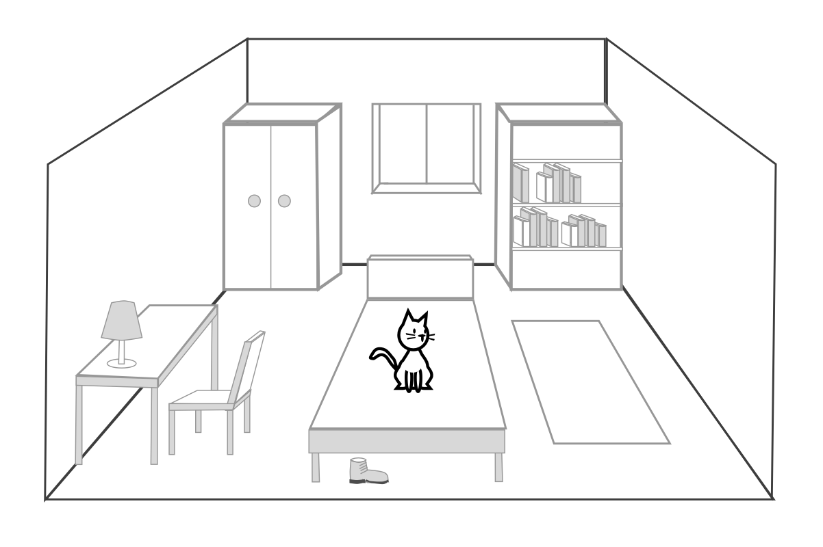
- There are books on the bookcase.
- There is a chair ______ the desk.
- The shoe isn’t on the bed. It is ______ the bed.
- There is a window ______ the wardrobe and the bookcase.
- The cat isn’t under the bed. The cat is ______ the bed.
- The window isn’t in front of the bed. It is ______ the bed.
E) Jesteś architektem wnętrz. Przygotowałeś/aś projekt kuchni. W pięciu zdaniach opisz przygotowany projekt. W każdym zdaniu wykorzystaj podane wyrazy. Użyj wyrażenia: There is / There are.

1 new kitchen This is a new kitchen.
2 four chairs _________________________
3 big table _________________________
4 fridge next to _________________________
5 cooker between _________________________
6 two windows _________________________
